# How to use the Searching-Engine

1 Setting Environment

Before compiling and running the source code, **pdfbox, jdbc and postgreSQL** needs to be downloaded, installed and properly added to the module path in java project.

The following links provide download and detailed instruction on how to configure each component:

Pdfbox: <https://www.tutorialspoint.com/pdfbox/pdfbox_reading_text.html>

Jdbc: <https://jdbc.postgresql.org/download.html>

PostgreSQL: <https://www.tutorialspoint.com/postgresql/postgresql_java.htm>

**2. Creating your own database by using PostgreSQL**

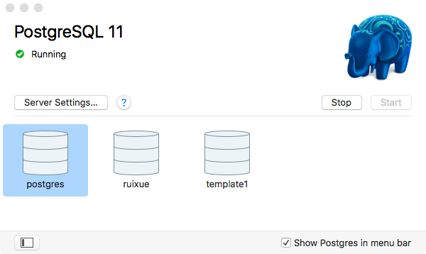

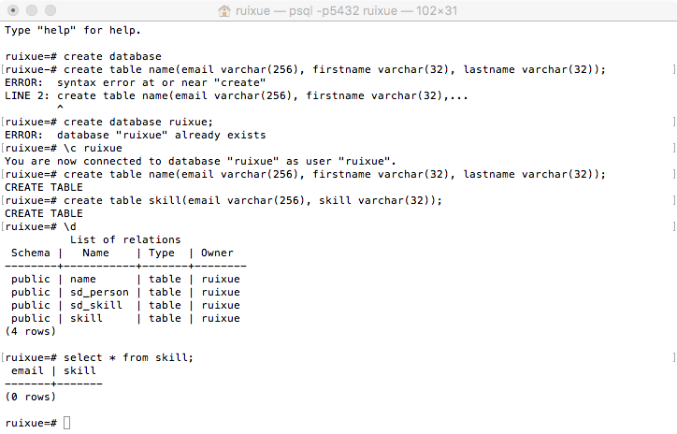

**3. Download and use the source code provided from the github**

Following the Gui Application:

**First: Searching skills from resume**

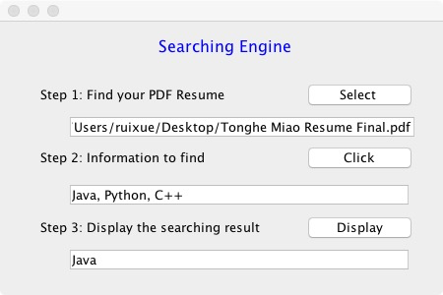

**Second: Storing skills and retrieving email from resume.**

